**Reactjs**

**Why react?**

* Reusable components supported by react makes it top choice with writing very less code.
* Learning curve is not stiff.

**Creating a react app(vite):**

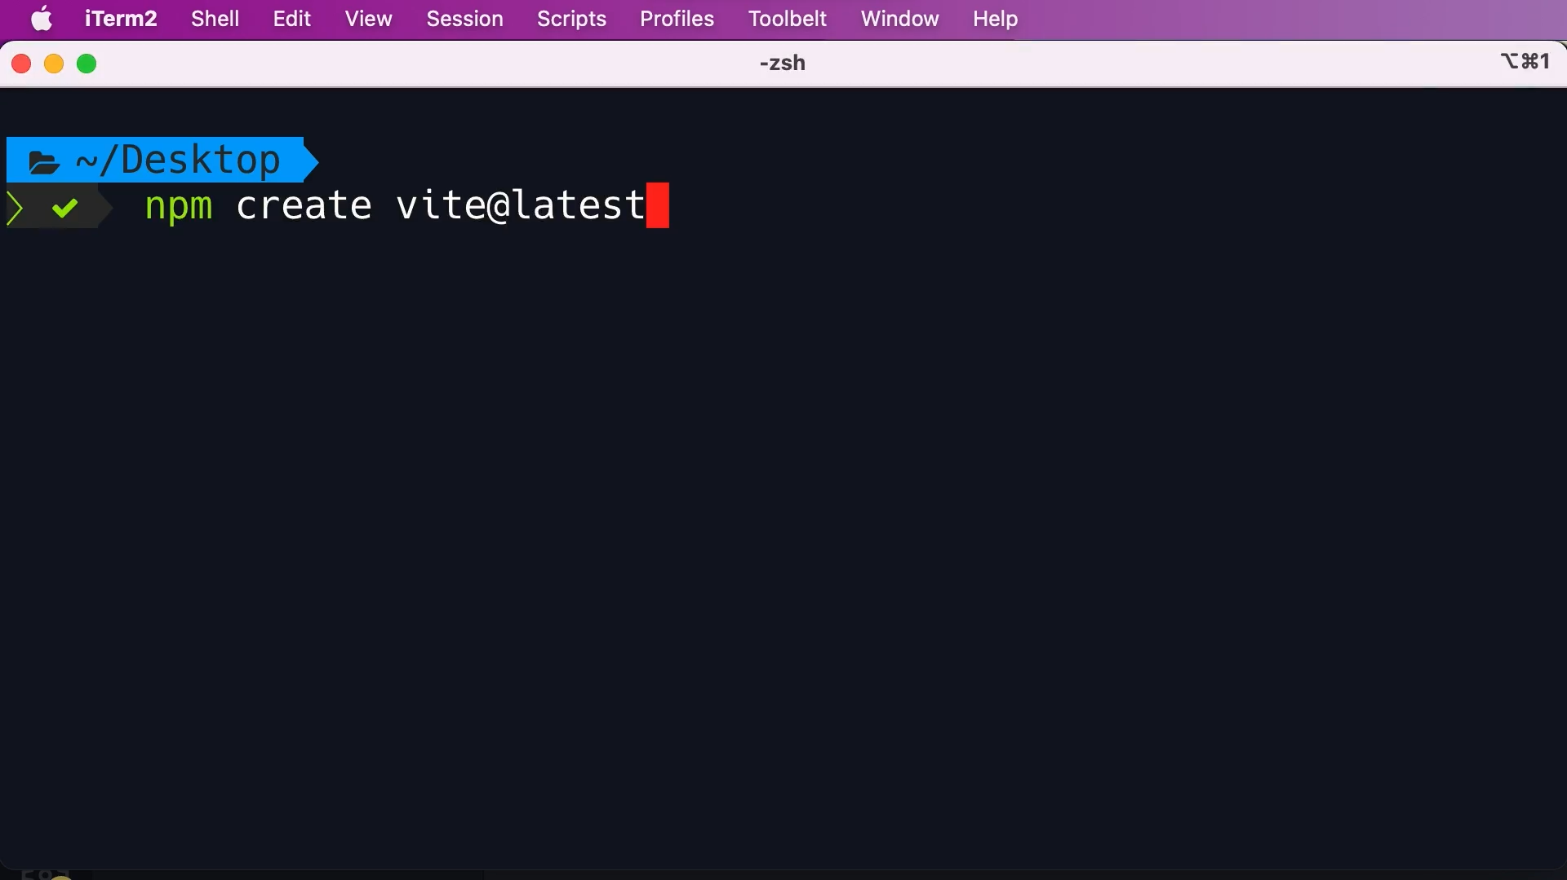

**Running application:**

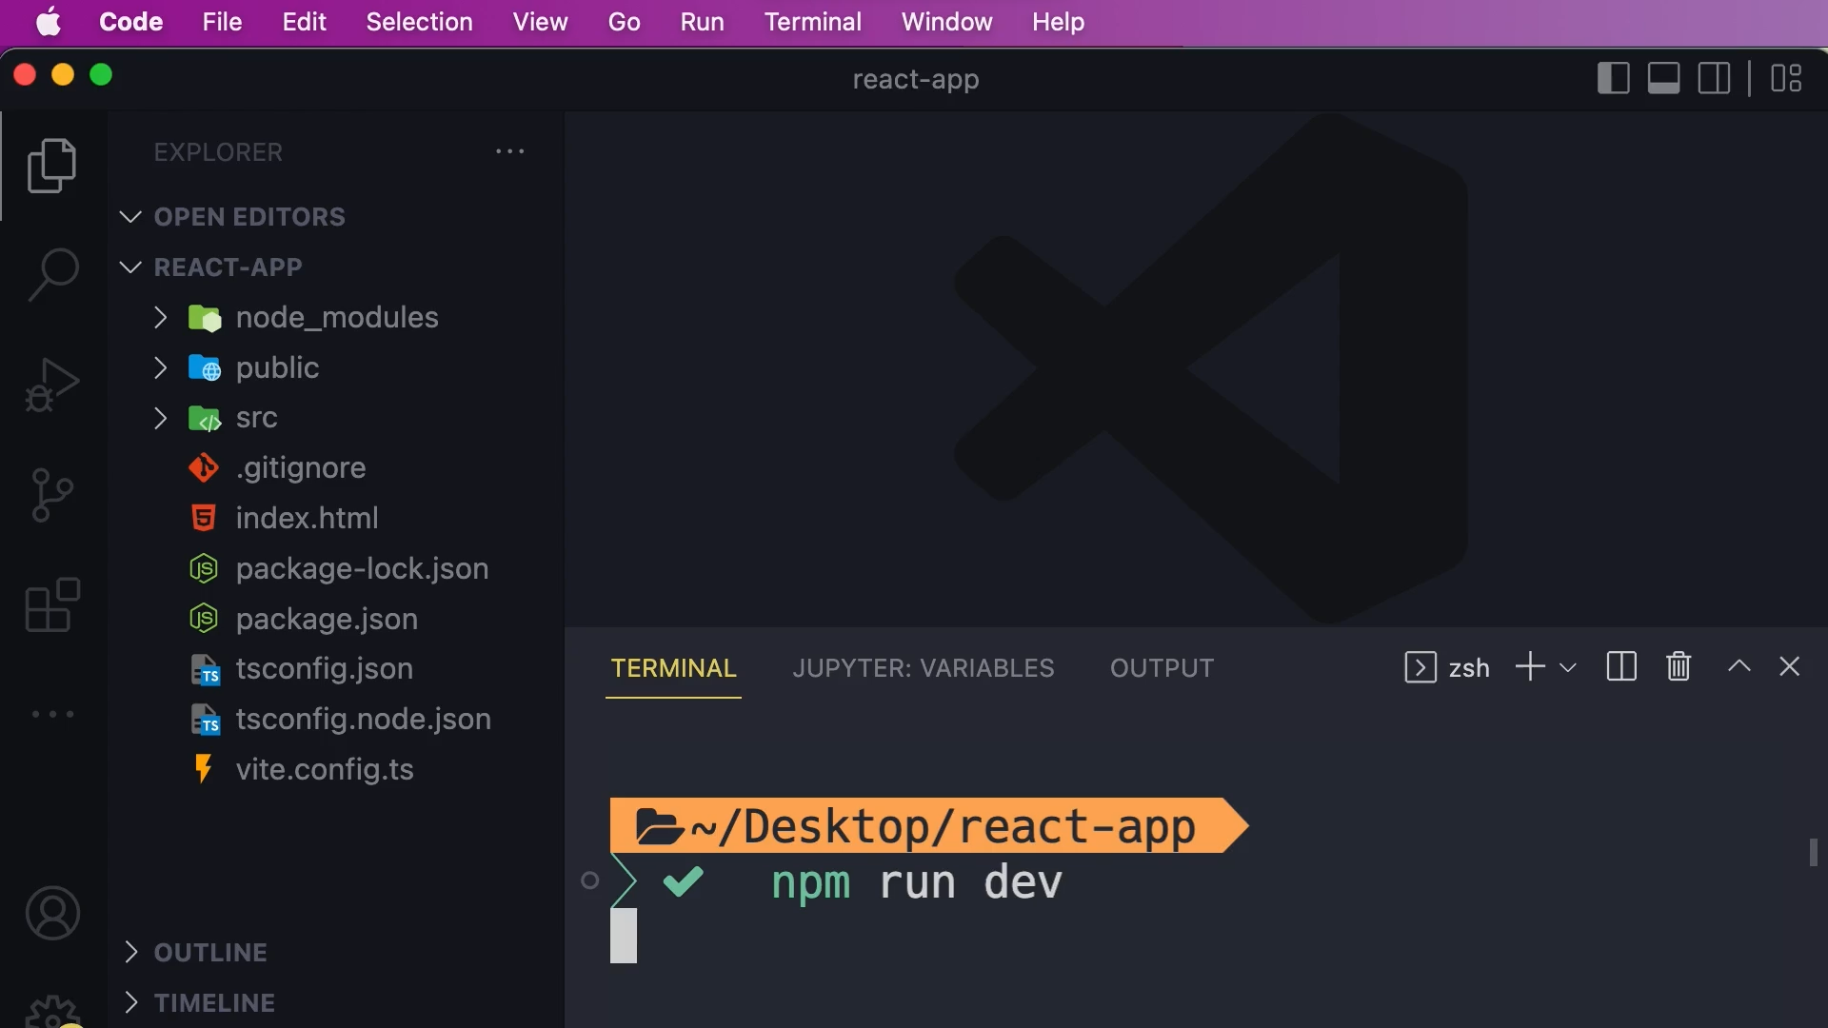

**React DOM:**

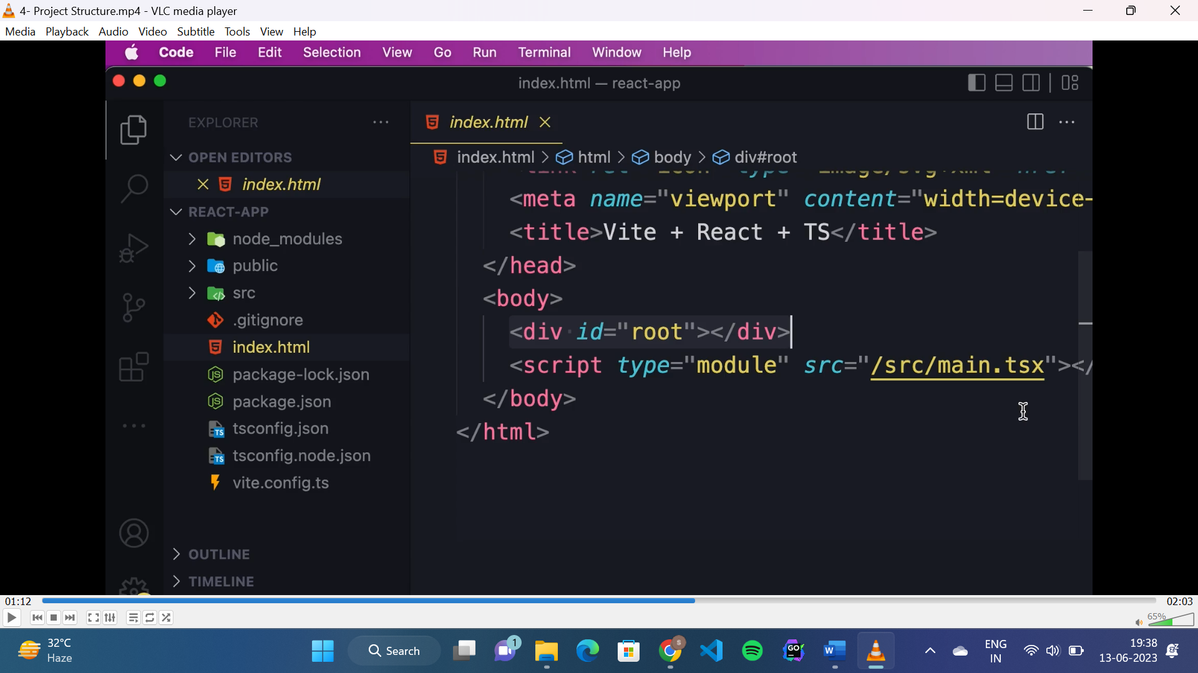

* “id=”root”” is the react container.
* “main.tsx” is the entry point of the application.

**React component:**

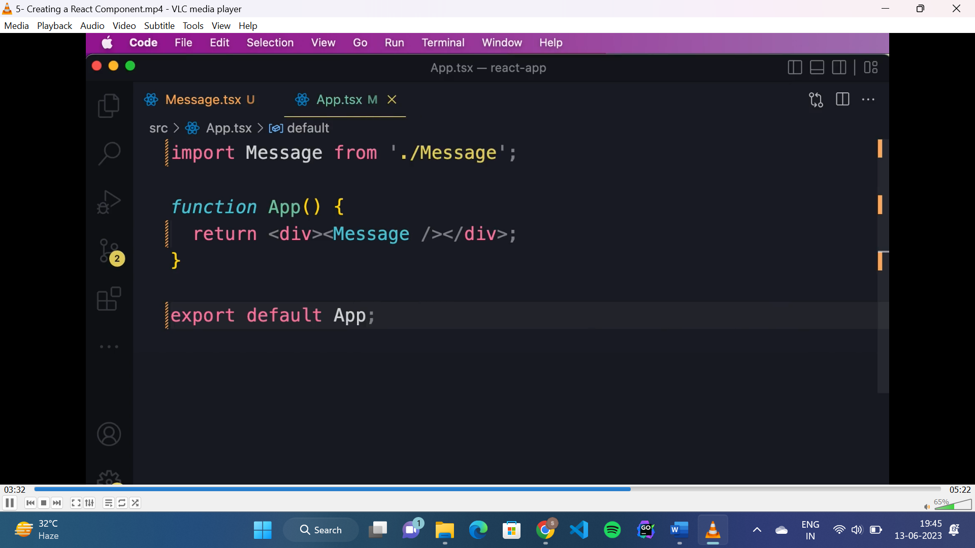

**Fragments:**

* Used to return multiple elements at a time.

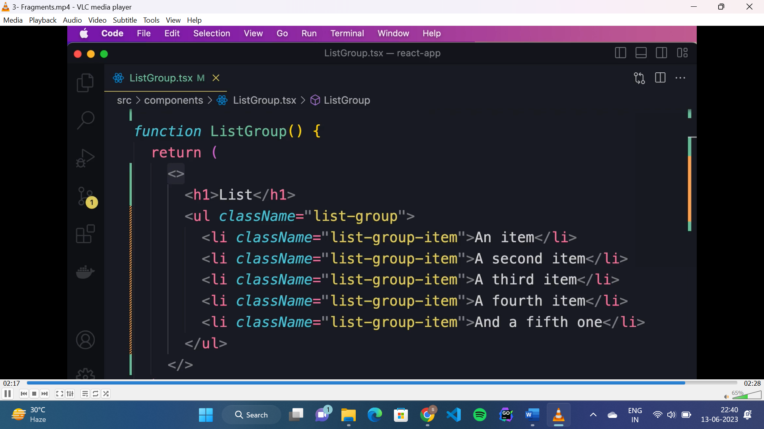

**Conditional rendering:**

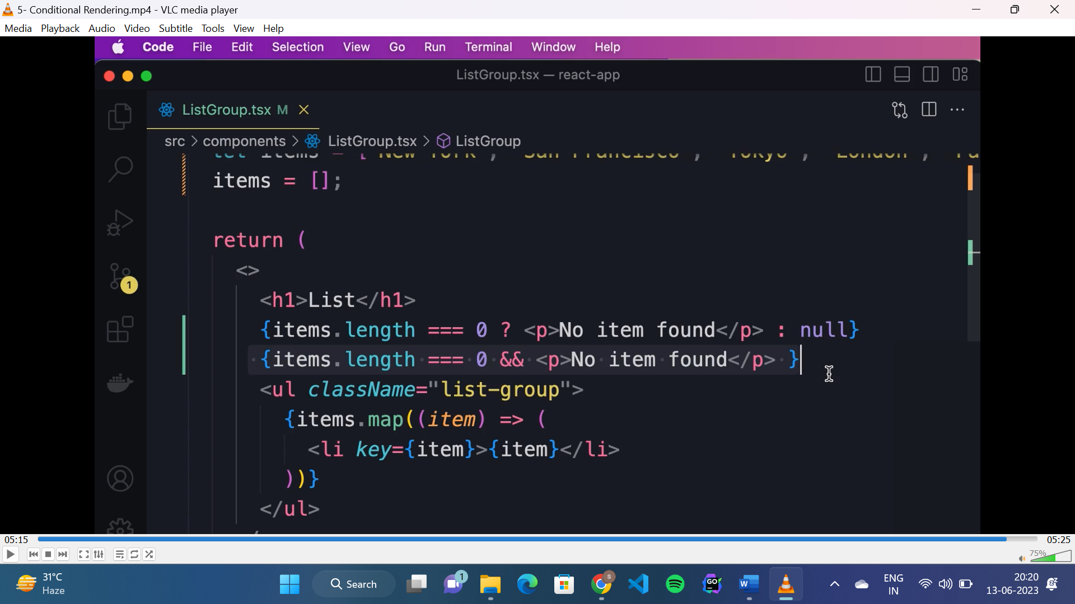

**Synthetic event:**

* It is a built in class in react but different browsers have different implementation of event object, so to make it cross browser, react made this wrapper over the browser event object.

**Handling event(TS):**

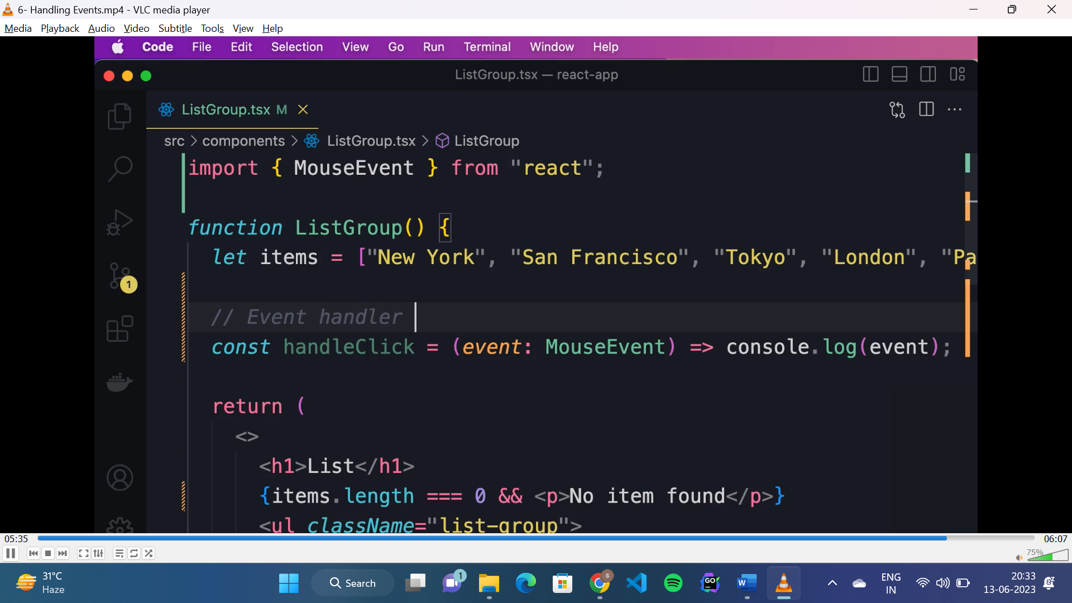

* To handle any mouse event, we need to define the event type as “event: MouseEvent”.

**Dynamically applying “active” class:**

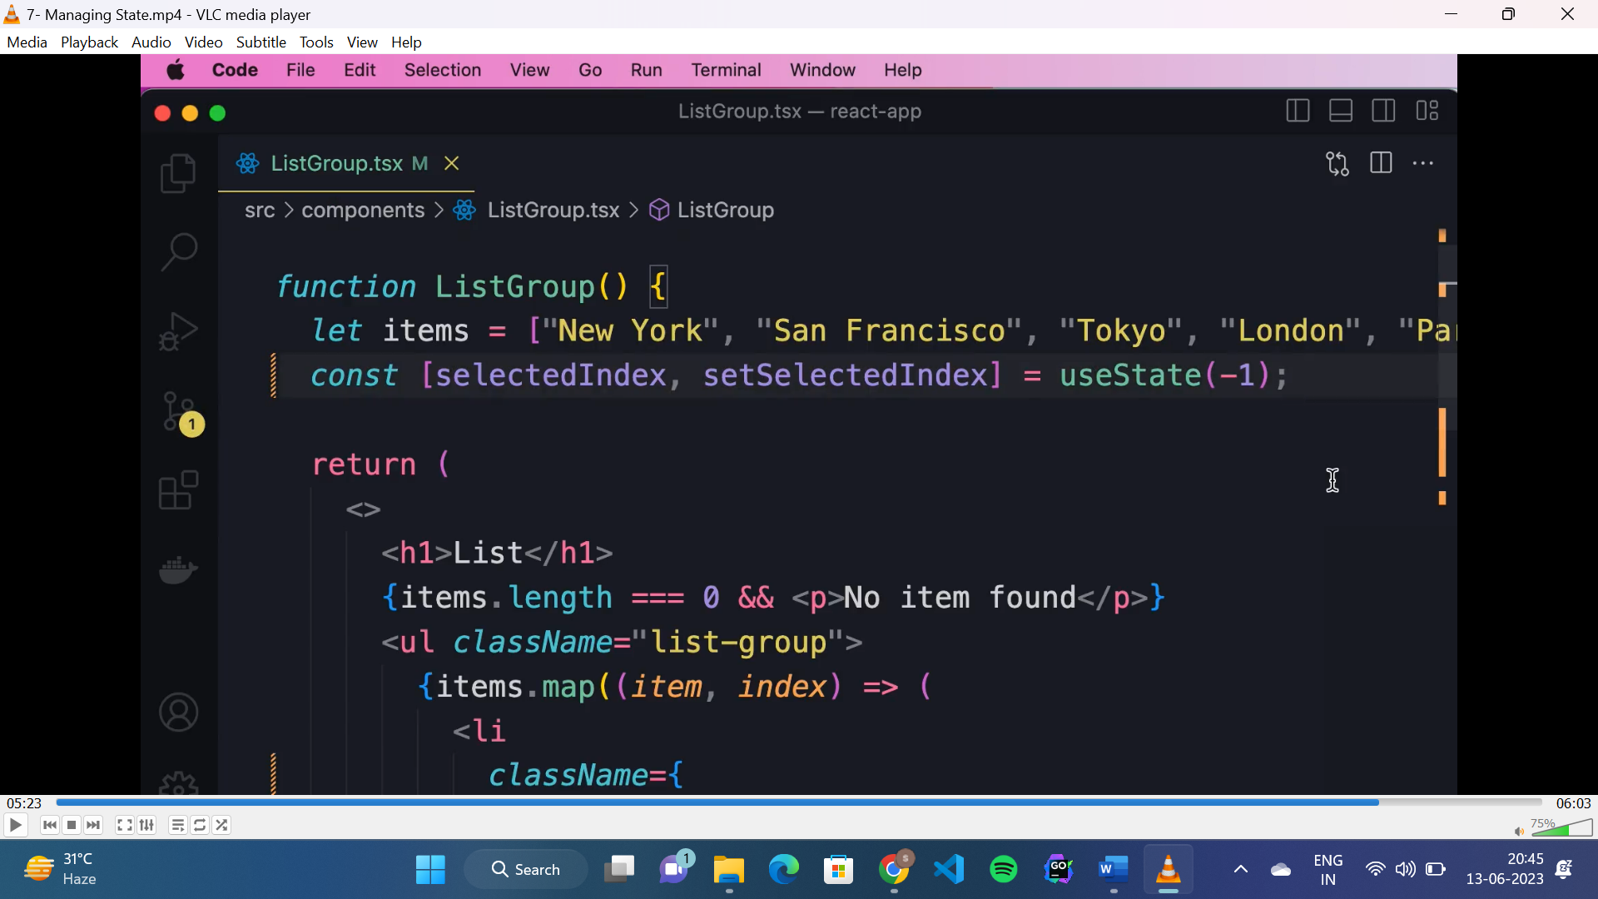

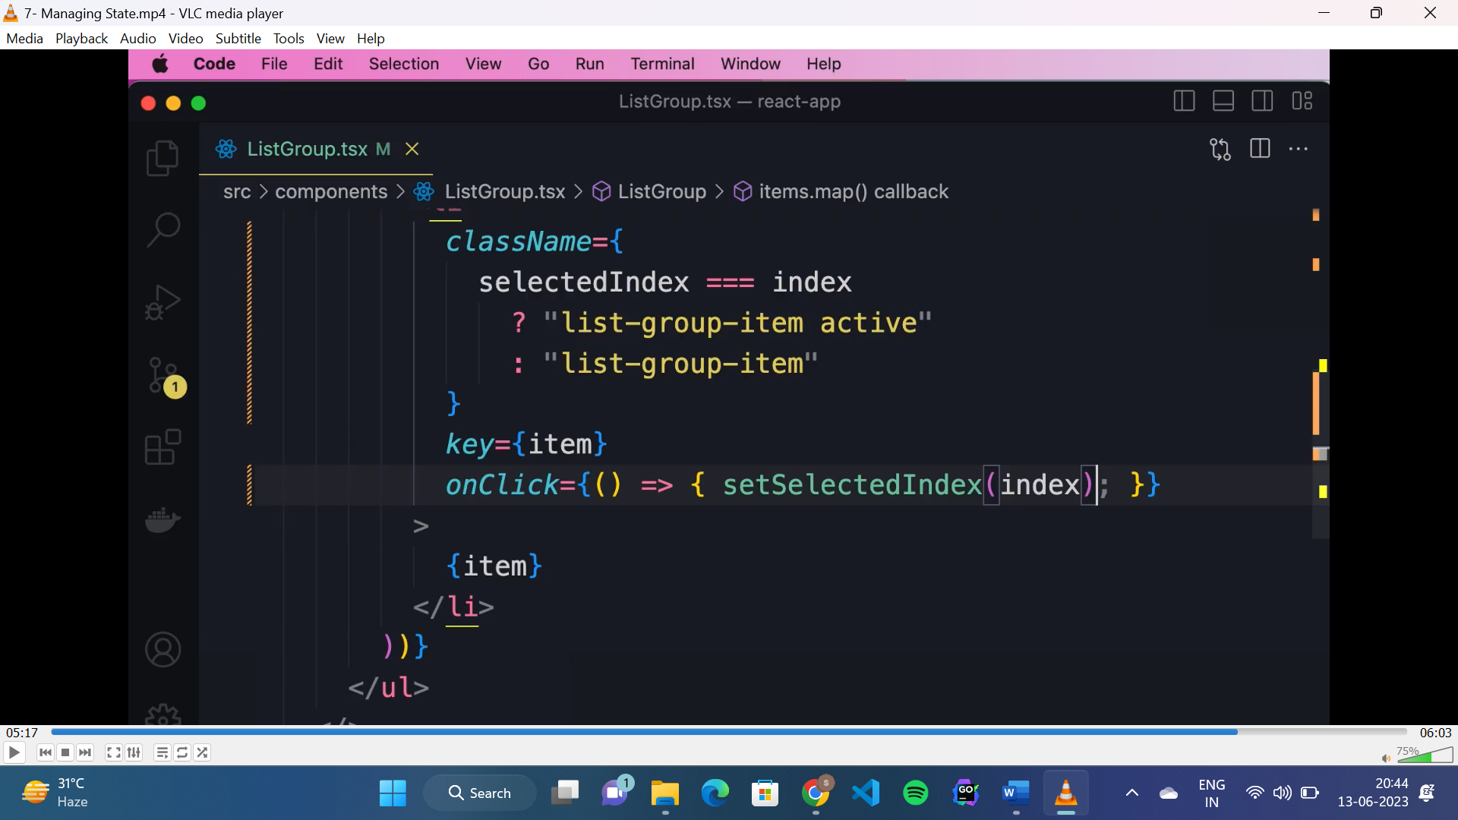

**TS interfaces:**

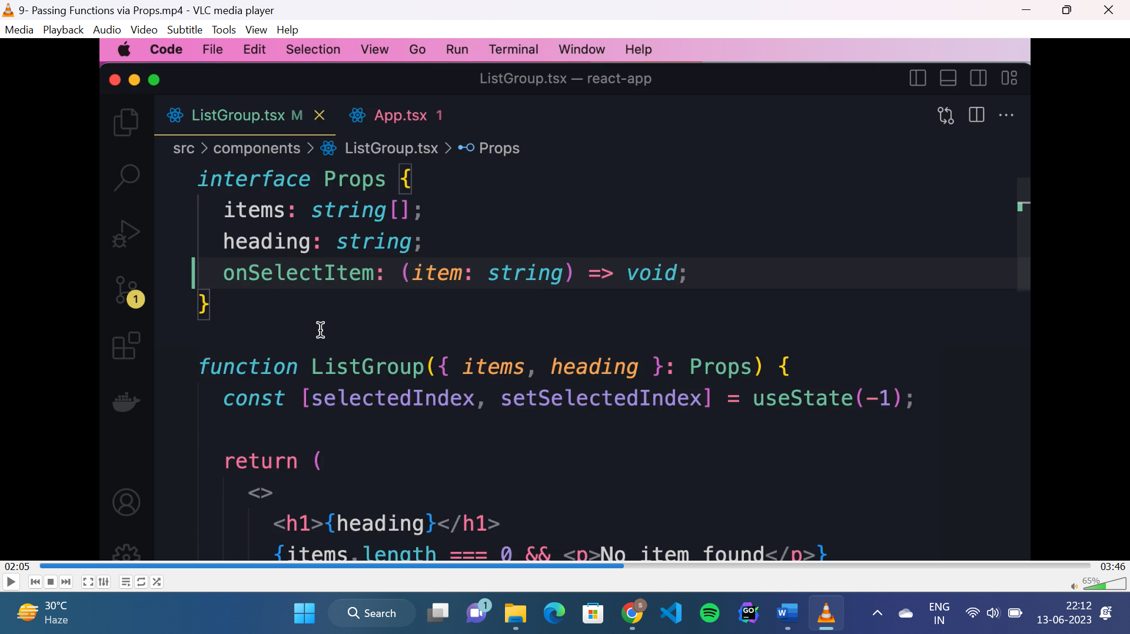

* Interfaces are used to define the shape of the input values(props) passed to a component.
* Starts with capital letter.

**Children prop:**

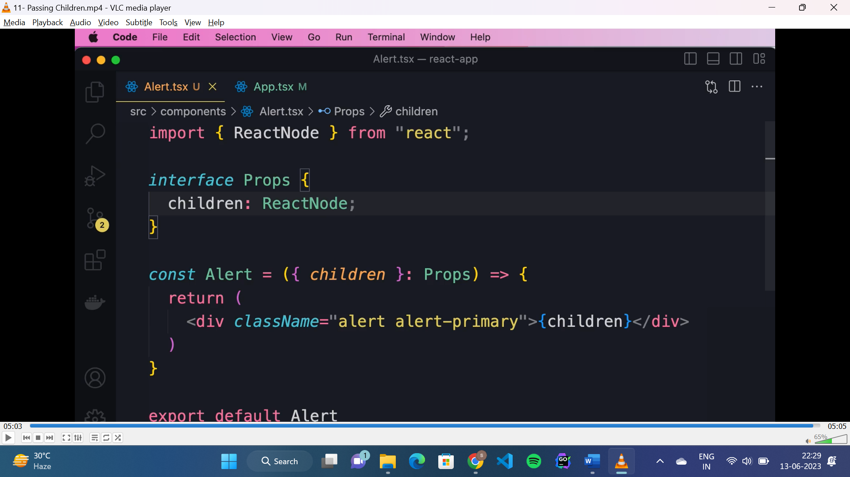

* To pass children as prop to a component:
* If it is a text: “children: string”
* If it is a HTML: “children: ReactNode”

**Props vs state:**

